Congratulations on purchasing Sales Mastery. As You’re an Action Taker I Wanted to Give You An Exclusive Offer…

[VSL]

Learn From Greg Cassar, The Man Who Taught Me Most of What I Know About Marketing… And Responsible for Helping His Collective Clients Creating Tens of Millions in Online Sales

I have spent close to $100k with Greg Cassar over the years to learn the very best methods in digital marketing and exactly how to get leads and turn them into customers.

Greg Cassar has built several multi-million dollar business and has consulted to digital marketing royality including the likes of Ryan Deiss, Frank Kern, Perri Belcher and even the founder of NLP Richard Bandler!

Recently, he retired his Mastermind program, The Collective (one which I was apart of for over two years) as his Amazon businesses were generating 7-figures all on their own; he decided it was time to scale back and have more time to live, surf and be with his family.
A position that most business owners dream to be in one day but few ever reach.

THE TRUTH

Truth be told, I owe much of my success or at least digital marketing strategy (which has kicked absolute butt) to Greg. I’ve known Greg for over a decade and his impact on me has been monumeutal. Greg helped me launch The Truth About Supplements, The Alpha Body, Eat Your Way To Abs, Maximus Mark Podcast and even built the first two versions of the Enterprise Fitness website. So after all these years it was only a matter of time before I managed to convince him to present to my Mastermind, Wolfpack.

AND WHAT A DAY IT WAS!

Imagine it; a room filled with hungry personal trainers, wanting to learn the in’s and out’s of marketing to be a formidable force from one of the very best in the world. All content taught was 100% on point for personal trainers and fitness professionals.

Greg gave us an entire day of tools, strategies and ideas to grow our businesses that even if only a tenth of what was presented got implemented, we would get more than our moneys worth.

Fortunately for us, we have a full-time videographer on staff, so of course we filmed the entire day with Greg.

Some times I have to pinch myself (like now)

Honestly, its been an honour to learn from Greg and an even bigger honour having him present at my Mastermind program Wolfpack. I can’t thank Greg enough for what his done for me and its been bittersweet to see his mastermind and mentorship come to a end. But what Greg has taught me, no one can ever take away.

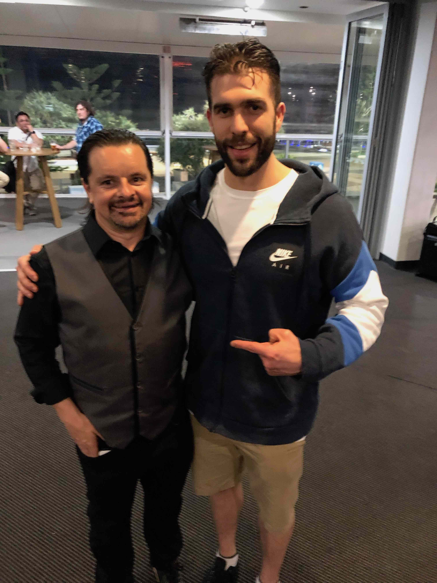
PICTURE OF ME AND GREG

When I told Greg I was putting together the Sales Mastery program for personal trainers he said to me; ‘you could teach them marketing too, infact you could use the videos we filmed at Wolfpack where I covered the in’s and out’s of successful entrepreneurship & marketing and using Google, Facebook, Instagram and Youtube for leads’.

IMAGE OF Say What gif

SAY WHAT!?

Greg Cassar, one of the leading digital marketing strategists in the world runs a private event for me at Wolfpack, teaching game changing information on Google, Facebook, Instagram, YouTube, Websites and Business- then allows me to use it to add value to Personal Trainers around the world.

WHAT GUY!

After discussing at length with Greg, we didn’t want to make these videos available to just everyone- I mean, Gregs private Collective clients pay $36,000 annually to be part of this program, so if word got out we were giving these presenations away at the price we are, some folks might get pissed.

Also we only wanted to make these available to action takers. Action takers like you; who have purchased Sales Mastery.

SO HERE IT IS… YOUR ONCE IN A LIFETIME OPPORTUNITY TO LEARN FROM GREG CASSAR…. INTERNET MARKETING LEGEND AND MULITI-MILLIONARIE…

As I mentioned before; Greg has retired his mentoring program, so learning from Greg is like learning from Yoda himself. It’s pretty freaking special.

Greg has allowed me to use all 4 of his modules in an exclusive ONCE AND ONCE only offer.

We are calling it Marketing Mastery and it’s only avaiable with purchase of Sales Mastery.

What You Get…

Module 1 | Winning the Game of Business

This isn’t just about making money- it’s about engineering your best life and explaining how to win the Entrepreneurs journey.

Here’s what you will learn:

- Understanding the profit triad to business success
- Growing Golden Gooses that lay Golden Eggs so you can have more money at the end of your life than life at the end of your money.
- Gregs number 1 book on financial intelligence and his biggest take aways that made him more cash
- Managing you’re A.N.T.S (annoying negetive thoughts)
- The mindset of a successful Entrepreneur and common pitfalls.

Module 2 | Financial I.Q.

To paraphase Greg, ‘it’s not just about more sales. You need to manage expenses, cashflow, days payable and inteventory ’. To be truly wealth, making more sales will only get you so far, you need to be able to manage, grow and invest what you have.

In module 2, you will learn:

- Key Financial I.Q. Principles for creating wealth and freedom
- Engineering More Profit into your business
- The Language of Business.
- Understanding business numbers and key levers of profit
- Ulitising The Profit Wedge to reduce expenses and maximise profit
- The Business Profit Accelerator Method. Ten levers that work in any business to create growth.

Module 3 | Effective Website Design and Driving Traffic & Leads from Google

So many personal trainers want to make Facebook ads before they understand how to design and build a website that actually converts prospects into leads. This is vital to success, otherwise you will be pissing away ad spend.

In this module we cover:

- Website design best practices for generating leads that result in sales.
- Moblie Vs Desktop browsing and site design. What you need to know to win business in our modern digital world.
- 5 Mobile site optimizmations that create more customers and enquires
- 7 MUST HAVE design elements for effective desktop site design.
- Simple wins to drive traffic to your site from Google
- Optimising content to rank so that your hard work, blog posts and videos actually get seen.
- Using Google Ad Express (Smart Campaign)

Module 4 | Building Trust and Authority. Lead Generation from Facebook and Instagram

Once you have a great converting website, the next step is to turn on the tap and drive traffic to it so you can start collecting leads and turning them into customers.

In this modules we teach you:

- The cheapest and most effective way to use Facebook to advertise your local personal training service.
- How to create the “I see you everywhere affect” using social media.
- A systematic way to warm up cold traffic and leads.
- The new way you should think about “direct response” Marketing.
- How to use remarketing and retargeting on Facebook and Instagram to collect more leads and customers.
- How to begin building a marketing funnel on Instagram and Facebook.

When you consider I paid $36,000 a year to be in Gregs Mastermind to help us systemised, automate and optimise our marketing that has helped grow Enterprise Fitness into the beast it is today… This is the kinda course you would be willing to walk over hot coals or sell the car to afford. It’s just that good. It’s the kinda stuff you wished you knew before you started.

Greg and I agreed that we wanted to make this a no brainer opportunity for all trainers. And considering you have already invested in Sales Mastery, we wanted to give you the whole package at a no brainer price that will simply delight you..

Marketing Mastery for Personal Trainers with Greg Cassar is just $197!

$300!

TODAY ONLY $197!

Now this is going to sound like a pitch…

And I guess it kinda is.. and I want you to know that I am ok with that because if you bite it will be freaking amazing for you. How can I be so sure?

Simple.

I learnt from Greg and it has made me so much smarter and profitable. More importantly it gave me time back. I was constantly trying to come up with ‘better content’ then Greg showed me how to make Facebook and Google Marketing work. It was truly game changing for me and Enterprise Fitness.

As this is a special deal, I have to stress THIS IS A ONE TIME AND ONE TIME ONLY OFFER. We have built the site so that once you click off, the link will expire and you won’t be able to revist this page.

So I am going to ask you to make a decision on this now…

[YES, I Want Instant Access To Marketing Mastery For Personal Trainers For Just $197]

[NO, I Don’t Want To Learn How To Learn From A Digital Marketing Legend]

Fortune favours the decisive and you would be better to decide no than maybe because in this case; there is no maybe.

This isn’t one of those, ‘I will think about it and come back to you deals’. Once you click off this page, this link will expire and it will be gone forever. You won’t get another email about this, you won’t see ads about it, I won’t offer or talk about it again.

This might sound like a hard sell but it’s really not. I just want to be super clear that these are the rules for purchasing Marketing Mastery for Personal Trainers.

In summary, if you want in and to up your Marketing Game ten-fold, hit the link below. If you don’t, that’s cool too, enjoy Sales Mastery.

[YES, I Want Instant Access To Marketing Mastery For Personal Trainers]

[NO, I Don’t Want To Learn How To Learn From A Digital Marketing Legend]

